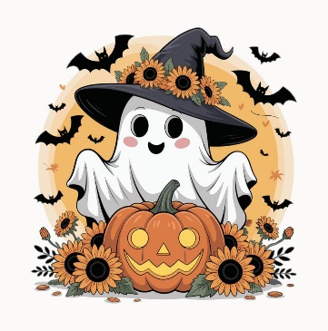 | Breakfast $1.00  Reduced $0.30  Adult and Non-Student Breakfast $2.50 | This institution  is an equal  opportunity provider | Lunch $2.00  Reduced $0.40  Adult and Non-Student Meals $4.50  *Menu subject to change | 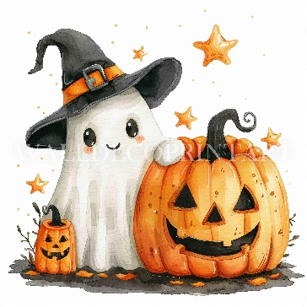
Breakfast Includes  Main Course  Side item  Fruit and Juice  Milk | PBJ Sandwiches  Grape, Strawberry or Raspberry  Cheese Stick & Crackers | 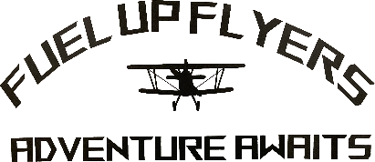 | Fruit and  Vegetable Bar  Served Daily | Milk  White and Chocolate  Served Daily
 |  | Oct. 5th-9th  National School Lunch Week | 1  Waffles or Bread  A: Grilled Cheese/Tomato  Soup  B: Cheeseburger | 2  Donut or Cereal  Pizza Pie Café  Cheese or Pepperoni
  5  Crumb Cake or Cereal  A: Big Top Franks  B: Chicken Sandwich | 6  Biscuit n Gravy or Muffin  A: Tightrope Tenders w/  Mac-nificent Mac & Cheese  B: Cheese Quesadilla |   7  Mini Puff Pancake or Cereal  A: Clown’s Club Sandwich  B: Corn Dog | 8  Breakfast Bowl or Bread  A: Ringmaster’s Nachos  B: Cheeseburger |   9  Donut or Cereal  Showstopper  Pizza Hut Pizza  Cheese or Pepperoni
12  Cheese Omelet or Cereal  A: Ham & Cheese Roll-up  B: Chicken Sandwich | 13  Pretzel w/Cheese or Muffin  A: Chicken & Gravy on  Mashed Potato  B: Cheese Quesadilla | 14  No School Fall Break | 15 | 16  Cafeteria Circus
19  Pancake on a Stick or Cereal  A: Chicken Alfredo  B: Chicken Sandwich | 20  Blueberry Bash or Muffin  A: Crispy Burrito  B: Cheese Quesadilla | 21  Breakfast Sandwich or Cereal  A: Popcorn Chicken Bowl  B: Corn Dog | 22  Pancake or Bread  A: BBQ Rib Sandwich  B: Cheeseburger | 23  Donut or Cereal  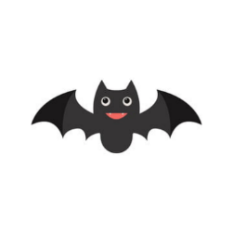  Marcos Pizza  Cheese or Pepperoni
26  Triple Berry Pastry or Cereal  A: Sloppy Joe  B: Chicken Sandwich | 27  French Toast Sticks or Muffin  A: Taco in a Bag  B: Cheese Quesadilla | 28  Strawberry Parfait or Cereal  A: Chicken Pot Pie  B: Corn Dog | 29  Breakfast Burrito or Bread  A: Chicken Tenders and  Chocolate pudding  B: Cheeseburger | 30  Donut or Cereal  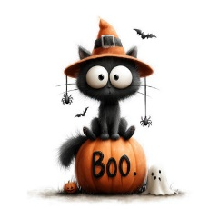  Pizza Hut Pizza  Cheese or Pepperoni

