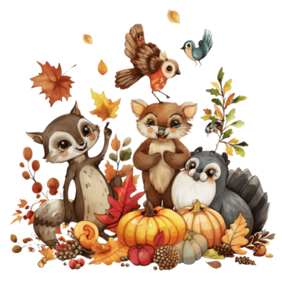 | Breakfast $1.00  Reduced $0.30  Adult and Non-Student Breakfast $2.50 | This institution  is an equal  opportunity provider | Lunch $2.00  Reduced $0.40  Adult and Non-Student Meals $4.50  *Menu subject to change | 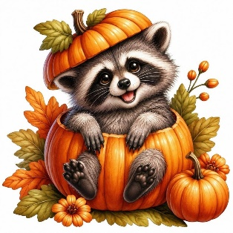
Breakfast Includes  Main Course  Side item  Fruit and Juice Milk | PBJ Sandwiches  Grape, Strawberry or Raspberry  Cheese Stick & Crackers | 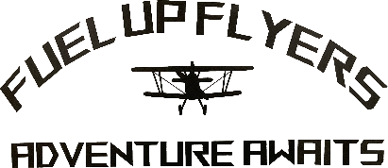 | Fruit and  Vegetable Bar  Served Daily | Milk  White and Chocolate  Served Daily
2  Crumb Cake or Cereal  A: Orange Chicken  B: Chicken Sandwich | 3  Cheese Omelet or Muffin  A: Chicken and Gravy over Mashed Potatoes w/Dinner Roll  B: Cheese Quesadilla | 4  Cinnamon Chip Scone or Cereal  A: Spaghetti & Meatballs  B: Corn Dog | 5  Breakfast Bowl or Bread  A: Grilled Cheese & Soup  B: Cheeseburger | 6  Donut or Cereal  Pizza Pie Café  Cheese or Pepperoni
9  Breakfast Calzone or Cereal  A: Chicken Alfredo  B: Chicken Sandwich | 10  Pretel or Muffin  A: Bean & Cheese Burrito  B: Cheese Quesadilla | 11  Mini Puff Pancake or Cereal  A: Pizza Rippers  B: Corn Dog | 12  Strawberry Parfait or Bread  A: BBQ Rib Sandwich  B: Cheeseburger | 13  Donut or Cereal  Pizza Hut Pizza  Cheese or Pepperoni
16  Bagel Dots or Cereal  A: Cheese Bites  B: Chicken Sandwich | 17  Eggo Waffle or Muffin  A: Taco in a Bag  B: Cheese Quesadilla | 18  Cinnamon Roll or Cereal  A: BBQ Pulled Pork Sandwich  B: Corn Dog | 19  Breakfast Sandwich or Bread  Thanksgiving Lunch | 20  Donut or Cereal  Marcos Pizza  Cheese or Pepperoni
23 | 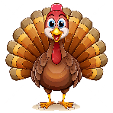  24 | 25  No School Thanksgiving Break | 26 | 27
30  Pancake on a Stick or Cereal  Pizza Pie Café  Cheese or Pepperoni |  |  | 